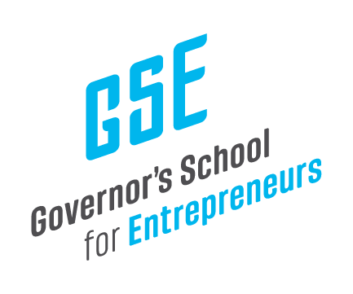

October 24, 2024

Mr. Jay Hartz
Legislative Research Commission Director
Sent Via Electronic Mail

Dear Mr. Hartz,

The Governor’s School for Entrepreneurs (GSE) is pleased to share the financial reports from our Fourth Quarter, covering the months of July, August, and September 2024 for FY 2024.

I welcome any questions or feedback on these reports.

Kind regards,

Anne

Anne Jewell
President & CEO
Governor’s School for Entrepreneurs

